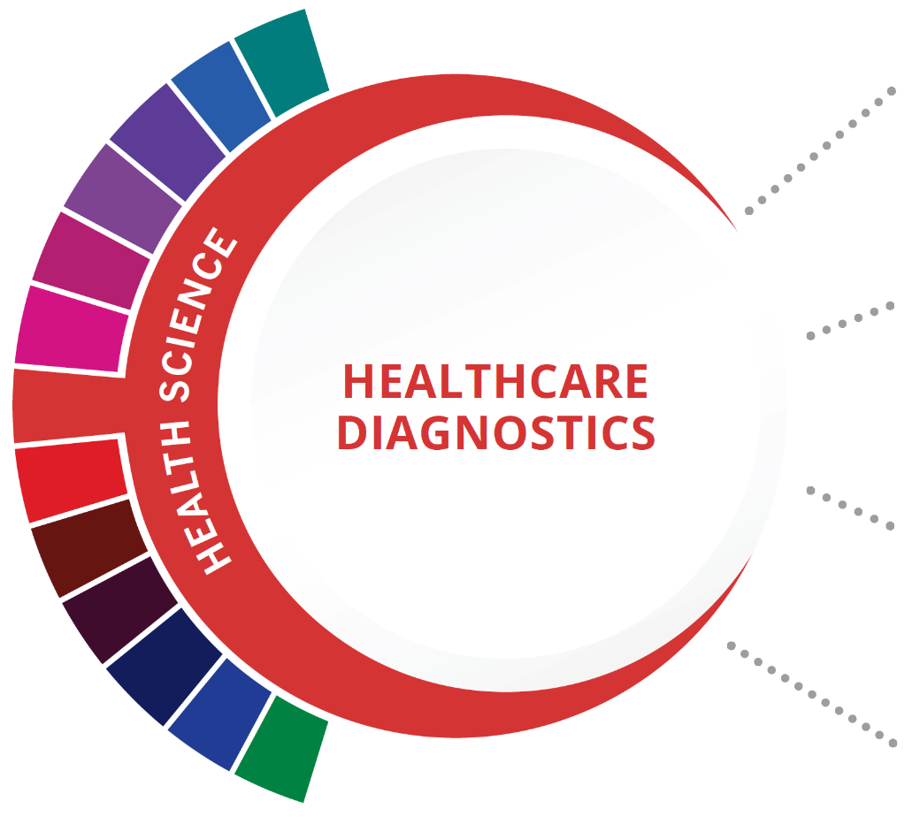
Statewide Program of Study: Healthcare Diagnostics; Health Science Career Cluster
Level 1 | Principles of Health Science
Level 2 | Medical Terminology
Level 3 | Health Science Theory/Health
Level 4 | Anatomy and Physiology  Practicum in Health Science
Occupations | Median Wage | Annual Openings | % Growth
Diagnostic Medical Sonographers | $69,909 | 495 | 35%
Phlebotomists | $30,597 | 1442 | 36%
Nuclear Medicine Technologists | $75,962 | 91 | 13%
Radiologic Technologists | $55,494 | 1196 | 19%
Magnetic Resonance Imagine Technologists | $68,661 | 217 | 21%
HIGH SCHOOL/ INDUSTRY CERTIFICATION | CERTIFICATE/ LICENSE* | ASSOCIATE’S DEGREE | BACHELOR’S DEGREE | MASTER’S/ DOCTORAL PROFESSIONAL DEGREE
Limited Licensed Radiology Technologist | Medical Sonographer | Nuclear Medical Technology/  Technologist | Nuclear Medical Technology/  Technologist | Radiologist
EKG/ECG Technician | Radiologic Technologist | Magnetic Resonance Imaging (MRI) Technology/  Technician | Medical Radiologic Technology/  Science Radiation Therapist | Radiologic Technology/  Science - Radiographer
Medical Laboratory Technician

Phlebotomy
Technician

Additional industry-based certification information is available on the TEA CTE website. For more information on postsecondary options for this program of study, visit TXCTE.org.

WORK BASED LEARNING AND EXPANDED
LEARNING OPPORTUNITIES
Exploration Activities: | Work Based Learning  Activities:
Health Occupation Students of America (HOSA) | Clinical rotations at a community wellness center, hospital, assisted living, nursing home

The Healthcare Diagnostics program of study introduces students to occupations and education opportunities related to performing complex medical laboratory tests for the diagnosis, treatment, and prevention of disease. This program of study may also include exploration into the opportunities associated with blood laboratories as well as radiologic technology and ultrasound technology.
The Health Science Career Cluster focuses on planning, managing, and providing therapeutic services, diagnostics services, health informatics, support services, and biotechnology research and development. To pursue a career in the health science industry, students should learn to reason, think critically, make decisions, solve problems, communicate effectively, and work well with others.

Successful completion of the Healthcare Diagnostics program of study will fulfill requirements of the Public Service or STEM Endorsement if the math and science requirements are met. Revised- July 2020

COURSE INFORMATION

COURSE  NAME | SERVICE ID | PREREQUISITES (PREQ)  COREQUISITES (CREQ) | Grade
Principles of Health Science | 13020200 (1 credit) | None | 9-10
Medical Terminology | 13020300 (1 credit) | None | 9-12
Health Science Theory/ Health Science Clinical | 13020400 (1 credit)  13020410 (2 credits) | PREQ: Biology | 10-12
Anatomy and Physiology | 13020600 (1 credit) | PREQ: Biology and a second science credit | 10-12
Practicum in Health Science | 13020500 (2 credits)  13020505 (3 credits)  13020510 (2 credits)  13020515 (3 credits) | PREQ: Health Science Theory and Biology | 11-12

FOR ADDITIONAL INFORMATION ON THE HEALTH SCIENCE CAREER CLUSTER, PLEASE CONTACT:
CTE@tea.texas.gov
https://tea.texas.gov/cte

(District) offers career and technical education programs in (types of programs offered). Admission to these programs is based on (admission standards). It is the policy of (District) not to discriminate on the basis of race, color, national origin, sex or handicap in its vocational programs, services or activities as required by Title VI of the Civil Rights Act of 1964, as amended; Title IX of the Education Amendments of 1972; and Section 504 of the Rehabilitation Act of 1973, as amended. It is the policy of (District) not to discriminate on the basis of race, color, national origin, sex, handicap, or age in its employment practices as required by Title VI of the Civil Rights Act of 1964, as amended; Title IX of the Education Amendments of 1972; the Age Discrimination Act of 1975, as amended; and Section 504 of the Rehabilitation Act of 1973, as amended. (District) will take steps to assure that lack of English language skills will not be a barrier to admission and participation in all educational and vocational programs. For information about your rights or grievance procedures, contact the Title IX Coordinator at (physical address of Coordinator) (email address of Title IX Coordinator), (phone number of Title IX Coordinator), and the Section 504 Coordinator at (physical address of Coordinator), (email address of Section 504 Coordinator), (phone number of Section 504 Coordinator)

